Date: 20th of October 2021

**Project Agreement**

**Part A: micro-web development**

Client details:

[business name & registration]

[representative]

[iva code if applicable]

*Project description:*

Micro-site featuring a gamified map leading the user to a pre-assigned location where an NFT can be retrieved from.

*Project duration:*

~**3 weeks** starting with the date of signing the agreement

*Stylistic direction:*

More details on the UI look to be given by the client and attached to the project work folder.

*Features:*

1. Connect the user’s wallet to the micro-website and filter whether they are whitelisted to play the game or not.
2. Game active only during full-moon specified period.
3. Import list of pre-decided locations provided by the Client
4. Retrieve the user’s location and calculate a radius within they can find mystery boxes in relation to the pre-decided location provided by the Client.
5. Get user location sharing permission + Get user live location
6. Map navigation via Google Maps API + Custom map stylization
7. Calculate route from User Live Location to Destination
8. 2D map visualisation and box assets
9. Prevent Desktop use & redirect to mobile

*Pricing:*

**.development**: Backend + Frontend + Web deployment [**£5000**]

**.web hosting:** recommended [Heroku](https://www.heroku.com/) (fees regarding hosting to be covered by the client)

**Note on pricing policy:**

1. Upfront Payment

50% upfront payment is required before the commencement of the project.

The amount is calculated based on the preliminary quote included in this document.

1. Modifications

Within the development quote, **minor modifications after each feedback round are included**.

Minor modifications are qualified as: minor stylistic changes (color scheme, existing UI placement on screen, replacing provided assets, altering font/ animation transitions/ proportions), minor functionality changes (changing the order of events), minor additions (adding a screen prompt)

**Major modifications & extra features will be charged between 10-100% of the value of the project per modification**, depending on the scale of the request. If features are requested l**ast minute**, they will be charged under emergency policy, at **40% extra added value**.

Major modifications include, but are not limited to: major stylistic changes (re-designing the UI of the app, designing custom assets), major functionality changes (adding extra screens, camera accessibility features, adding a new concept interaction etc.), major additions (complex screen prompts, gamified interactions etc.).

1. Final amount

This document is providing a preliminary quote and project timeline only. The final amount might change depending on whether extra features or modifications are requested during the development process.

*Project phasing & timeline*

| Stage | Deliverables | Date |
| --- | --- | --- |
| 1 | Main framework rough update | *by 03.11.2021* |
| 2 | App draft for testing | *by 08.11.2021* |
| 3 | Final version deployed on web | *by 15.11.2021* |

*Licensing*

The developer reserves the right to reuse and repurpose code, as well as retaining the right of ownership and copyright under open software premises. No further license agreement is required at this point.

*Agreement closed between:*

**RRUII**

(Infiltrate SRL),

Represented by Andreea Bunica

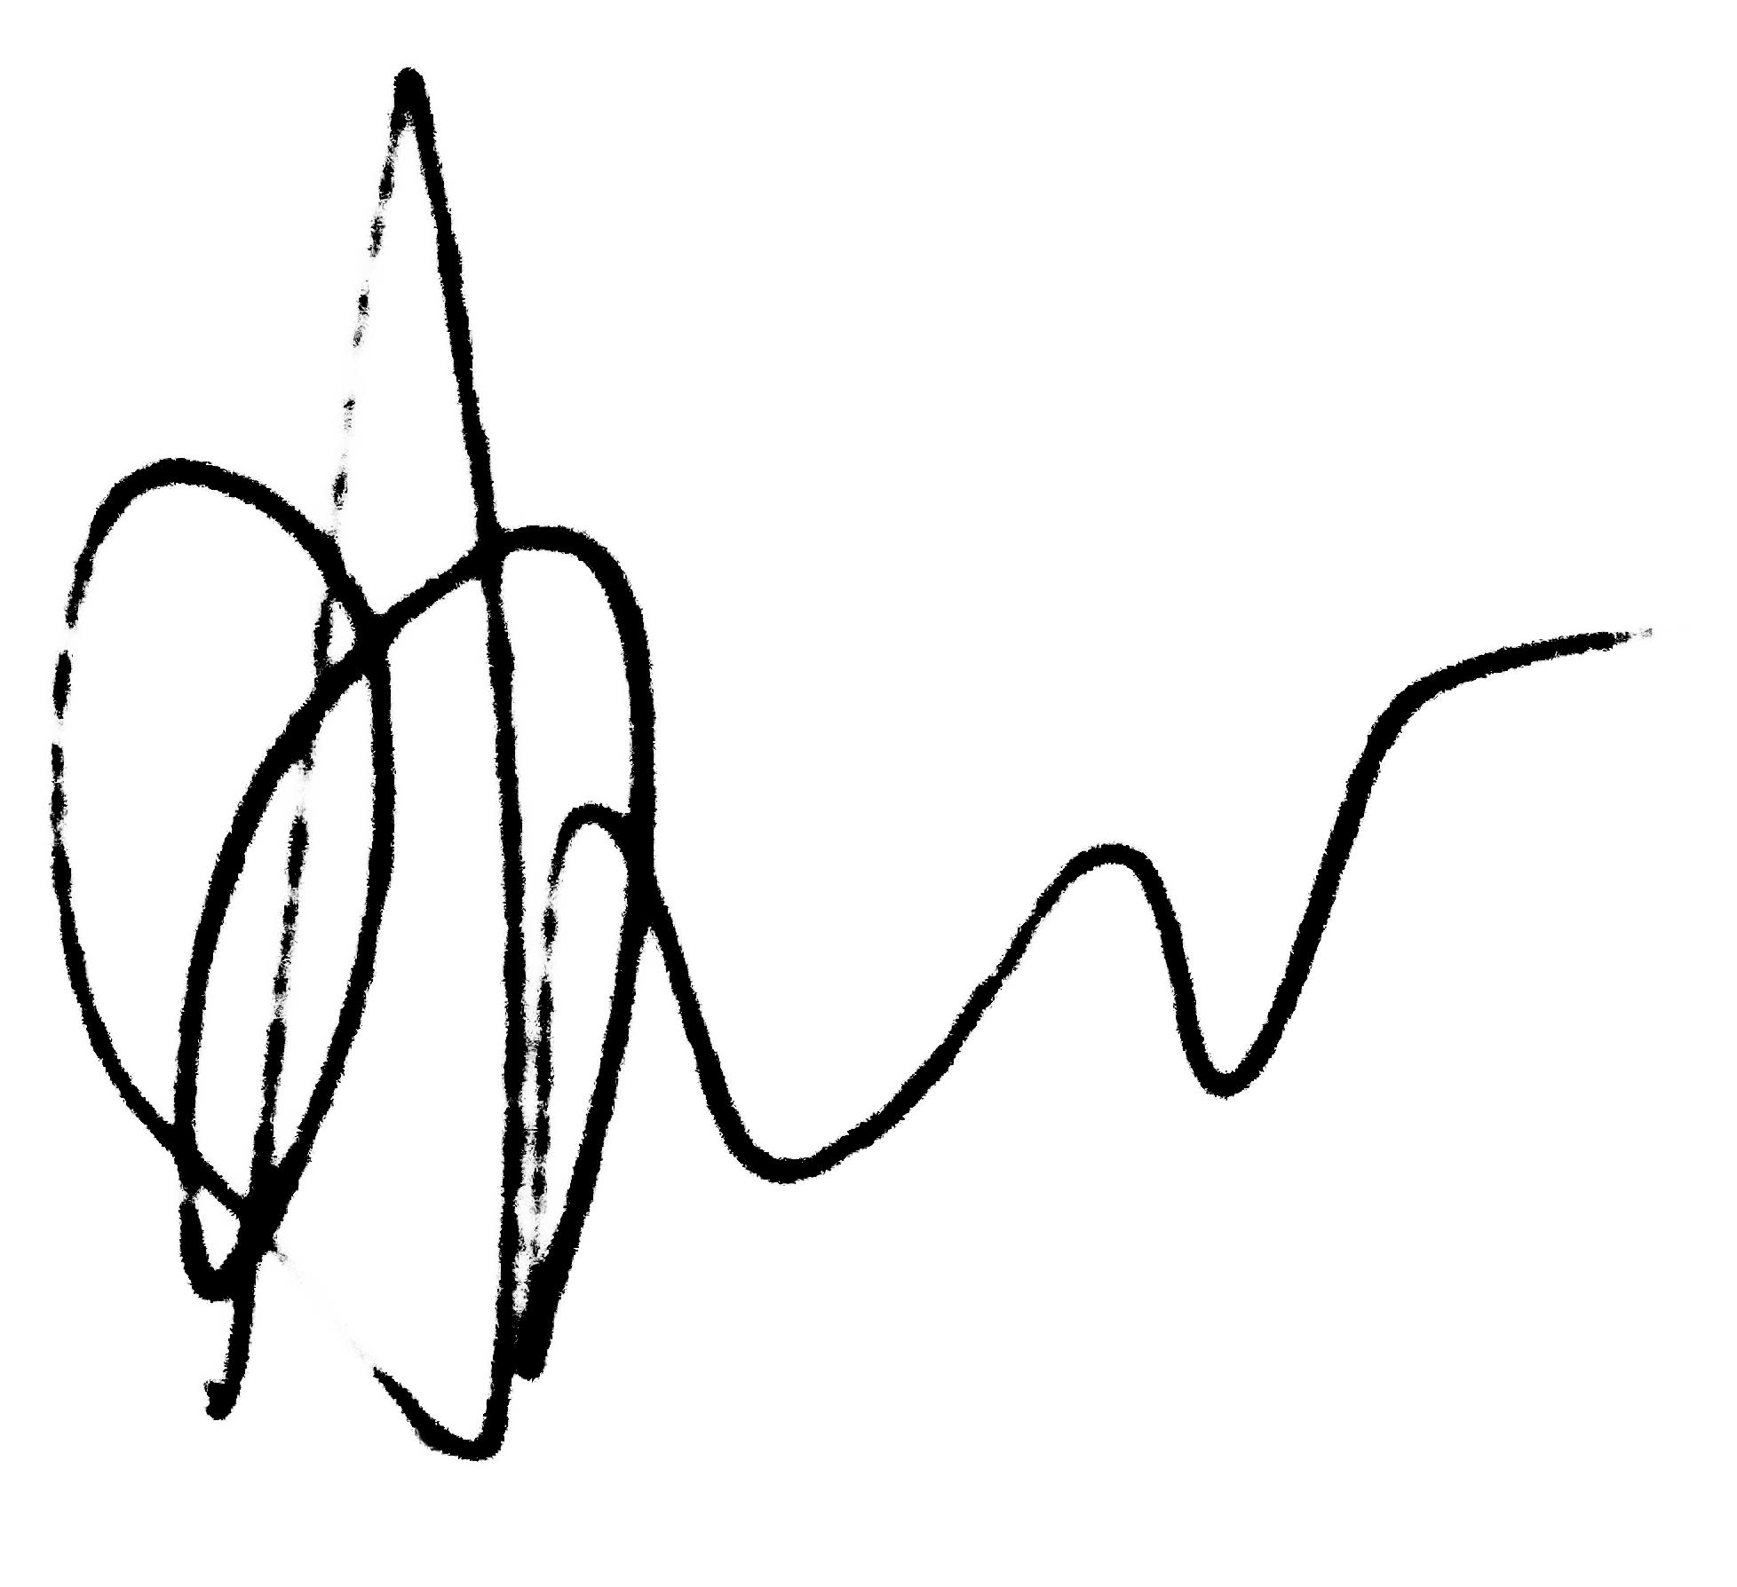

At *20th of October 2021*

[client details]

Represented by [representative name]

Signature: